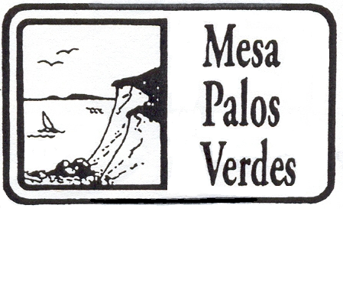

Mesa Palos Verdes Homeowners Association

Annual Meeting Agenda
Ridgecrest Intermediate School
Wednesday June 19, 2019 7:00 PM

- Welcome and Call to Order – Joe DeVenuto. President

- Pledge of Allegiance

- Approval of Agenda

- Welcome and Introduction of Guest Speaker – Joe DeVenuto, President

Marty Foster

- Acceptance of Annual Meeting 2019 Minutes- Para Karunatileka, Secretary

- Financial Reports: - Treasurer
Annual Financial Report - April 1, 2018 thru March 31, 2019
Proposed Annual Budget for 2019 – 2020

- Election of Officers 2019-2020. Nominations from the floor accepted.
Officers
President: Joe DeVenuto
Vice-President: Michael Garr
Secretary: Para Karunatileka
Treasurer: Wendy Louttit
Community HOA rep: Vacant
Zone Directors
1): Maureen Edwards 6): Hermia Lee
2): Vacant 7): Jesse Cordova
3): Peter Barrett 8): Maria del
Carmen Singer
4): Anne St. Cyr 9): Ardi Tavakol
5): Shera Finkel 10): Vacant

- Committee Reports
  - Neighborhood Watch

- Unfinished Business
  - Status of Cal Water Crest Facility Usage – Joe DeVenuto
  - Beautification Projects – Joe DeVenuto

- New Business

- Residents Comments – Forum for items not on the Agenda (max. 3 minutes per resident)

- Prize Drawing and Adjournment

